**World Quant University**

**Professor: Harry Wang**

**Algorithms II**

Nikolas Lippmann Pareschi - [nikolaslippmann@gmail.com](mailto:nikolaslippmann@gmail.com)

**Assignment 4: Fibonacci Heaps, VanEdmeBoas and Disjoint Sets**

### Problem: Fibonacci heap

Can a Fibonacci heap degenerate to a structure that has exactly one node in the root list, with a linear list appended to it? Describe how this structure can occur, or prove that it is not possible.

Yes, it can degenerate. We take the proof and example from: *“Advanced Algorithms and Data Structures”, page 244, Martin Held*

*If only insert and Delete Min operations are carried out, then a Fibonacci heap is a binomial heap after every Delete Min operation. By induction, Every Delete Min results in a consolidation phase during which pairs of trees which have root nodes of the same order are linked.*

*If no consolidation occurs (since no suitable DeleteMin operation is carried out) then a Fibonacci heap with n nodes may degenerate to one single tree, or even to an unsorted linked list (of n root nodes) or an “unary” tree of height n-1.*

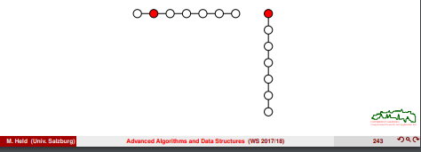

I provided a complete python code for generation and deletion, provided by [1].

Last but not least, I built a similar structure to the described structure in the following [2]:

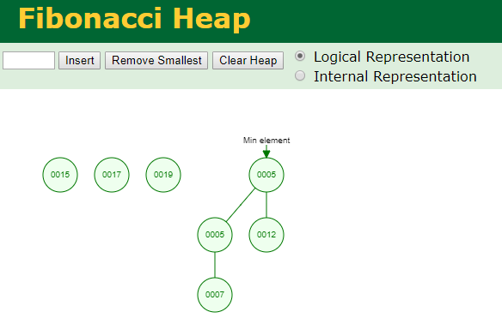

Removing procedures to degenerate and showing the links:

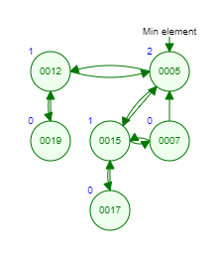

Further degeneration:

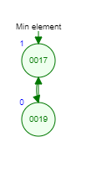

[1] <https://codereview.stackexchange.com/questions/176421/fibonacci-heap-in-python>

[2] <https://www.cs.usfca.edu/~galles/visualization/FibonacciHeap.html>